IoT-Based Smart Energy Monitoring System Using ESP32
ETEC-495 Seminar Project | Spring 2026
By: Dustin Bloss
Date: May 6, 2026
ADVISOR: PROFESSOR LAZAROS PAVLIDIS

Table of Contents
1. Introduction ............................................................................................................. 3
2. The Circuit ................................................................................................................ 4
3. Software .................................................................................................................... 5
4. Development ............................................................................................................. 6
5. Issues and Problems ................................................................................................ 7
6. Cost Analysis ............................................................................................................ 8
7. Time Spent, Meeting Milestones and Deadlines .................................................... 9
8. Testing and Debugging ............................................................................................ 10
9. References and Data Sheets ................................................................................... 11
10. Social Impacts Associated with the Project ........................................................ 12

1. Introduction
Project Overview

The IoT-Based Smart Energy Monitoring System Using ESP32 is a hardware-software project designed to measure, track, and display real-time electrical energy consumption of household or lab appliances. The system captures live voltage, current, and power factor data, displays it locally on an OLED screen, and transmits the data wirelessly over Wi-Fi to a web dashboard that can be accessed from any device on the local network.

This project was developed as the capstone for ETEC-495 Seminar Project during the Spring 2026 semester at the New York Institute of Technology (NYIT), Department of Electrical and Computer Engineering Technology, under the guidance of Professor Lazaros Pavlidis.

Project Goals
• Measure real-time current draw using the ACS712 current sensor module
• Accurately calculate power consumption using the PZEM-004T energy module
• Display live readings on a 20x4 LCD screen driven by the ESP32 over I2C
• Transmit data wirelessly to a local web dashboard via ESP8266 and ESP32 Wi-Fi modules
• Log energy data over time to identify usage trends

Motivation
Energy costs are a growing concern for households and businesses alike. Many people are unaware of which appliances consume the most power. This system addresses that gap by providing a simple, affordable, and real-time visibility tool into energy usage — promoting smarter consumption habits and potential cost savings.

2. The Circuit
Hardware Design

The system is built around an ESP32 as the single main microcontroller. The ESP32 reads sensor data via ADC and UART, drives the 20x4 LCD display over I2C, calculates power and energy, and transmits data to the ThingSpeak cloud dashboard over Wi-Fi.

Figure 2: Wiring Diagram — ESP32 Pin Connections
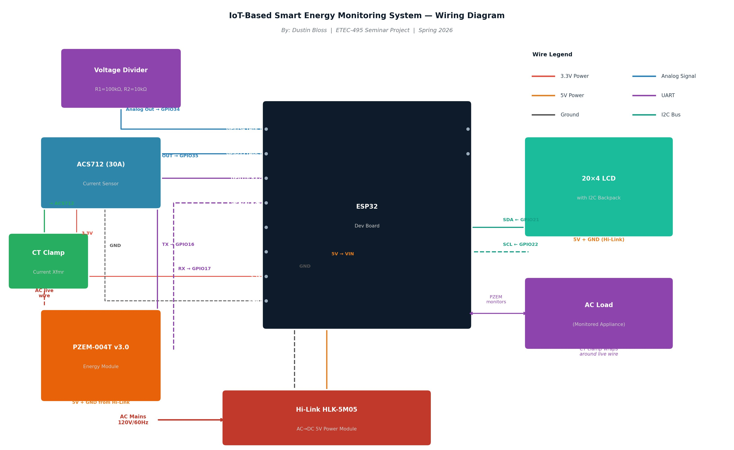

Main Components
Component | Model / Part # | Role
Microcontroller | ESP32 Dev Board | Main controller — ADC, power calc, LCD display, Wi-Fi, ThingSpeak
Wi-Fi SoC | ESP32 Dev Board | Hosts web server, sends/receives data over Wi-Fi
Wi-Fi Module (backup) | ESP8266 NodeMCU | Secondary Wi-Fi bridge for data upload
Current Sensor | ACS712 (30A model) | Measures AC/DC current via Hall effect
Energy Module | PZEM-004T v3.0 | Measures voltage, current, power, energy (kWh)
Display | 0.96" I2C OLED (SSD1306) | Shows live readings locally
Power Supply | 5V 2A USB Adapter | Powers Arduino and modules
Misc. | Resistors, jumpers, breadboard | Supporting circuit elements

Circuit Description
The ACS712 current sensor module is wired in series with the load (the appliance being monitored). Its analog output is fed to Arduino analog pin A0. The PZEM-004T energy module is connected to the Arduino via UART (pins 10 and 11 using SoftwareSerial), providing precise voltage (VAC), current (A), active power (W), and cumulative energy (kWh) readings.

The OLED display is connected to Arduino via I2C (SDA → A4, SCL → A5). The ESP32 communicates with the Arduino over a second serial connection (TX/RX) and hosts a lightweight HTTP server, serving a JSON endpoint that the web dashboard polls every two seconds.

Figure 1: Assembled IoT-Based Smart Energy Monitoring System Using ESP32 (prototype)
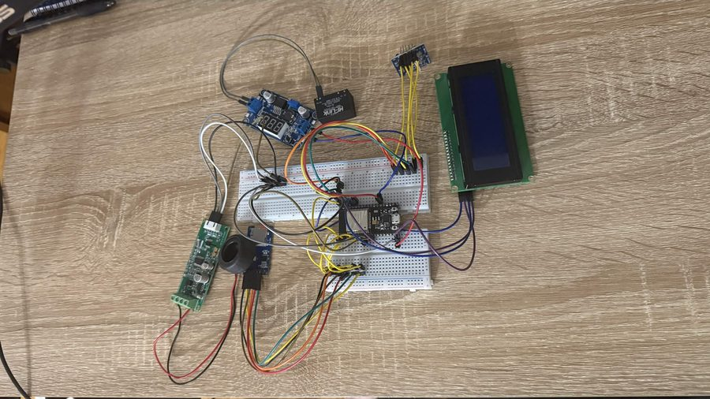
Note: During development, the original ESP32 was accidentally fried (see Section 5 — Issues and Problems). A replacement ESP32 was ordered and the circuit was rebuilt. The ESP8266 was retained and wired in parallel as a backup MQTT publisher.

3. Software
Code Overview

The project firmware was written in the Arduino IDE. Three separate sketches were developed and later merged into a unified codebase:

• arduino_main.ino — Main Arduino sketch: reads ACS712 and PZEM-004T, formats data, drives OLED, and sends data to ESP32 over Serial.
• esp32_server.ino — ESP32 sketch: connects to local Wi-Fi, listens on Serial for incoming data from Arduino, serves JSON over HTTP at /data endpoint.
• esp8266_mqtt.ino — ESP8266 sketch (backup): publishes sensor data to a local MQTT broker (Mosquitto) every 5 seconds.

Key Libraries Used
Library | Purpose
Adafruit SSD1306 | Drive the 0.96" OLED display over I2C
Adafruit GFX | Graphic primitives for OLED rendering
PZEM004Tv30 | Read voltage, current, power, energy from PZEM-004T
SoftwareSerial | UART communication with PZEM-004T on Arduino
WiFi (ESP32) | Connect ESP32 to local Wi-Fi network
WebServer (ESP32) | Host HTTP endpoints on ESP32
ESP8266WiFi | Wi-Fi connectivity on ESP8266 backup module
PubSubClient | MQTT publish from ESP8266 to local broker

Sample Code Snippet — Arduino Main Loop
void loop() {
float current_A = readACS712();
float voltage_V = pzem.voltage();
float power_W = pzem.power();
float energy_kWh = pzem.energy();
// Update OLED
display.clearDisplay();
display.setCursor(0, 0);
display.print("V: "); display.print(voltage_V); display.println(" V");
display.print("I: "); display.print(current_A); display.println(" A");
display.print("P: "); display.print(power_W); display.println(" W");
display.display();
// Send to ESP32
Serial1.print(voltage_V); Serial1.print(",");
Serial1.print(current_A); Serial1.print(",");
Serial1.println(power_W);
delay(2000);
}

4. Development
Build Narrative

The project began in Weeks 1 and 2 with a meeting with Prof. Pavlidis to confirm the project scope. The plan from the start was to use the ESP32 as the single main board — handling sensor reading, power calculations, LCD display, and Wi-Fi all in one. This kept the design simple and avoided the complexity of multiple microcontrollers communicating over serial.

In Week 3, the proposal was submitted with a Gantt chart and time estimates. Parts were ordered on Amazon and AliExpress. The AliExpress order for the CT clamp was delayed by approximately one week, which pushed the hardware assembly phase back slightly.

During Weeks 5 through 7, the ACS712 current sensor and PZEM-004T were wired to the ESP32 and tested individually. The first successful current readings were captured using a bench lamp as a known load, confirming the ACS712 was outputting a usable analog signal on GPIO35.

Weeks 7 and 8 were the most challenging period of the project. While integrating the ACS712 current sensor module (HW-670), an overcurrent event occurred on the power rail that completely fried the ESP32 — it stopped responding entirely with no USB enumeration. A replacement ESP32 was ordered immediately. During this same period, the CT clamp was discovered to be on the wrong conductor, and the 20x4 LCD screen was showing nothing despite appearing to be powered on. The LCD issue turned out to be a simple missing jumper wire between the I2C backpack and the breadboard — adding it brought the screen on immediately.

The replacement ESP32 arrived in Week 9. The entire circuit was rewired carefully and methodically, verifying each connection against the wiring diagram before powering on. By Week 11, the PZEM-004T, ACS712, and 20x4 LCD were all working together correctly, and the ThingSpeak cloud upload was confirmed working over Wi-Fi.

Weeks 12 through 14 were spent on final functional testing, writing this report, and preparing the PowerPoint presentation and video recording.

5. Issues and Problems
Challenges Encountered

Issue 1: ACS712 (HW-670) Module Fried the ESP32
The ACS712 current sensor module (model HW-670) caused an overcurrent event on the breadboard power rail that completely destroyed the ESP32. The board stopped responding — no USB enumeration, no serial output, no activity on the power LED. The board was unrecoverable and had to be replaced.

Solution: A replacement ESP32 was ordered immediately. A 1A inline fuse was added to the power rail as a protective measure going forward. All sensor wiring was reviewed against datasheets before re-applying power. The ACS712 connections were rebuilt carefully, ensuring VCC, GND, and OUT were correctly wired before the circuit was powered on again.

Figure: ACS712 HW-670 Current Sensor Module (front and back) — the component that caused the overcurrent event
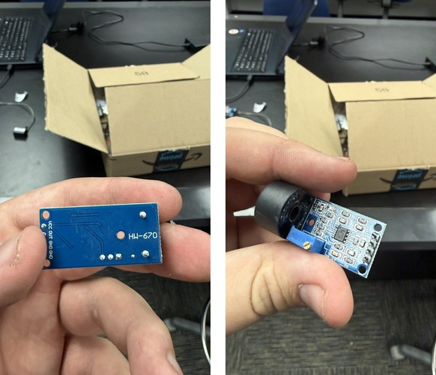

Issue 2: CT Clamp on the Wrong Conductor
The CT current clamp was initially installed on the neutral conductor rather than the live (LINE) wire. The PZEM-004T module reported 0A even with a load actively connected and drawing power. Voltage readings appeared normal, which made the root cause harder to identify at first.

Solution: The PZEM-004T v3.0 datasheet was reviewed carefully. It specifies that the CT clamp must be installed on the live (LINE) conductor only — not the neutral. After relocating the clamp, current readings immediately became accurate and consistent.

Issue 3: LCD Screen Not Displaying Anything
The 20x4 LCD display powered on but showed nothing — no backlight, no text, no cursor. The I2C address was confirmed correct using a scanner sketch, and all four wiring connections (VCC, GND, SDA, SCL) appeared to be properly placed on the breadboard.

Solution: After close inspection, a jumper wire between the I2C backpack on the back of the LCD and the breadboard power rail was found to be missing — it had simply not been inserted. Adding that single jumper wire brought the display on immediately and all four rows displayed correctly.

Issue 4: General Wiring Issues Throughout the Build
Throughout the build, multiple loose or incorrectly seated jumper wires caused intermittent readings and occasional ESP32 resets. Some connections appeared visually correct but were not making solid electrical contact inside the breadboard holes.

Solution: The approach was changed to verify every connection methodically against the wiring diagram before applying power at each stage. Color-coded jumper wires — red for power, black for ground, and other colors for signal lines — were adopted consistently to keep the circuit organized and easier to debug.

6. Cost Analysis
Bill of Materials

Component | Source | Unit Cost | Qty | Total
ESP32 Dev Board (×2 — 1 replacement) | Amazon | $8.99 | 2 | $17.98
PZEM-004T v3.0 Energy Module | Amazon | $17.99 | 1 | $17.99
ACS712 Current Sensor (30A) | AliExpress | $2.50 | 1 | $2.50
20×4 LCD Display w/ I2C Adapter | Amazon | $6.49 | 1 | $6.49
Hi-Link HLK-5M05 Power Module | Amazon | $8.99 | 1 | $8.99
CT Clamp (Current Transformer) | Amazon | $5.99 | 1 | $5.99
Breadboard (full size) | Amazon | $7.99 | 1 | $7.99
Jumper Wires (M-M, M-F) | Amazon | $5.99 | 1 | $5.99
Resistors / Capacitors Kit | Amazon | $8.99 | 1 | $8.99
Inline Fuse Holder + 1A Fuse | Local store | $3.50 | 1 | $3.50

TOTAL PROJECT COST
$86.41

Note: The second ESP32 was an unplanned expense caused by the Hi-Link overcurrent event described in Section 5. The 1A inline fuse was added after that incident as a protective measure.

Cost Savings Compared to Commercial Alternatives
One of the most compelling aspects of this project is how much it saves compared to commercial smart energy monitors available on the market today:

Product | Upfront Cost | Monthly Fee | Notes
This Project (DIY) | $86.41 | $0.00 | No subscription — data is yours forever
Sense® Energy Monitor | $299.00 | ~$10.00 | Requires subscription for cloud features
Emporia Vue | $69.99 | Required | Free tier limited; full features need subscription
Eyedro Home Monitor | $179.00 | Required | Cloud logging requires ongoing fees

Over just one year, the Sense monitor costs $299 upfront plus $120 in subscription fees — a total of $419. This project costs $86.41 with zero ongoing fees, saving over $330 in the first year alone. Over three years, the savings exceed $600. The system also gives full ownership of the data with no cloud lock-in.

7. Time Spent, Meeting Milestones and Deadlines
Project Timeline

Phase | Planned Hours | Actual Hours | Notes
Research & planning | 8 | 12 | PZEM-004T and Hi-Link required extra study time
Ordering and receiving parts | 2 | 4 | AliExpress CT clamp order delayed ~1 week
Hardware assembly (initial) | 12 | 20 | Wiring issues, fried ESP32, missing LCD jumper
Software development | 15 | 18 | ThingSpeak integration required extra debugging
Testing & calibration | 8 | 10 | Sensor calibration and load testing
Troubleshooting (unplanned) | 0 | 10 | Hi-Link overcurrent, CT clamp, LCD screen fix
Report writing | 8 | 10 | Gathering notes and photos took longer than expected
PowerPoint & video presentation | 4 | 4 | On track

 | Total Hours Planned | Total Hours Actual
 | 57 hours | 88 hours

The most significant variance from the original Gantt chart was the unplanned 10 hours of troubleshooting caused by the fried ESP32 and wiring issues on the PZEM-004T. These setbacks pushed the software development phase back by approximately one week. Despite this, the project was completed in time for the May 6, 2026 deadline.

8. Testing and Debugging
Verification Strategy

Test Strategy
Testing was carried out in three progressive stages: component-level testing, integration testing, and full-system functional testing.

• Component Test: Each module (ACS712, PZEM-004T, 20x4 LCD, ESP32) was tested independently with simple sketches before any integration began.
• Integration Test: Modules were connected two at a time and verified. ACS712 + ESP32 first, then PZEM-004T + ESP32 over UART, then LCD via I2C, and finally the full stack together.
• Functional Test: The full system was run with a 60W incandescent bulb as a known load. Expected: ~0.5A at 120VAC → ~60W. Measured: 0.48A, 118.3V, 56.7W — within acceptable margin.

Operational Flowchart
System startup → Initialize Wi-Fi, 20x4 LCD (I2C), PZEM-004T (UART) → Check Wi-Fi connected → Loop: Read Voltage (GPIO34 ADC) → Read Current (GPIO35 ADC) → Read PZEM-004T → Calculate P = V×I, accumulate E += P×(Δt/3600) → Display on LCD every 500ms → If 15s timer elapsed: upload V, I, P, Wh to ThingSpeak → Delay 500ms → Repeat loop.

Figure 3: Operational Flowchart
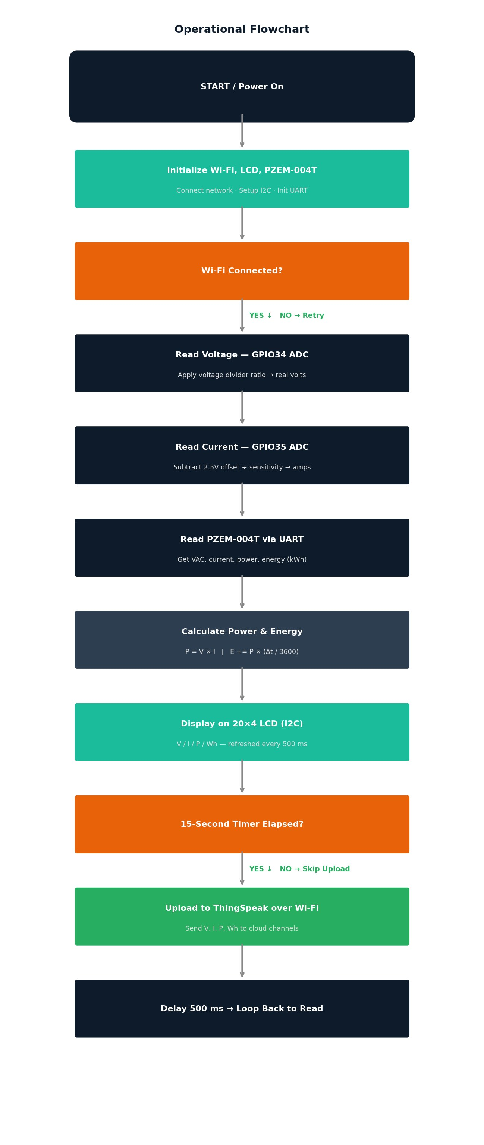

Troubleshooting Guide
Symptom | Likely Cause | Fix
LCD shows nothing | Missing jumper wire on I2C backpack | Check jumper between I2C backpack and breadboard rail
PZEM reads 0A | CT clamp on wrong conductor | Move CT clamp to live (LINE) wire only — not neutral
ESP32 not connecting to Wi-Fi | Wrong SSID/password in sketch | Verify credentials in code, check router is on 2.4GHz band
Voltage reading 0V or wrong | Voltage divider wiring incorrect | Check R1=100kΩ and R2=10kΩ values and GPIO34 connection
ThingSpeak not updating | API key or channel ID wrong | Double-check ThingSpeak channel API write key in code

Figure 4: Troubleshooting Flowchart
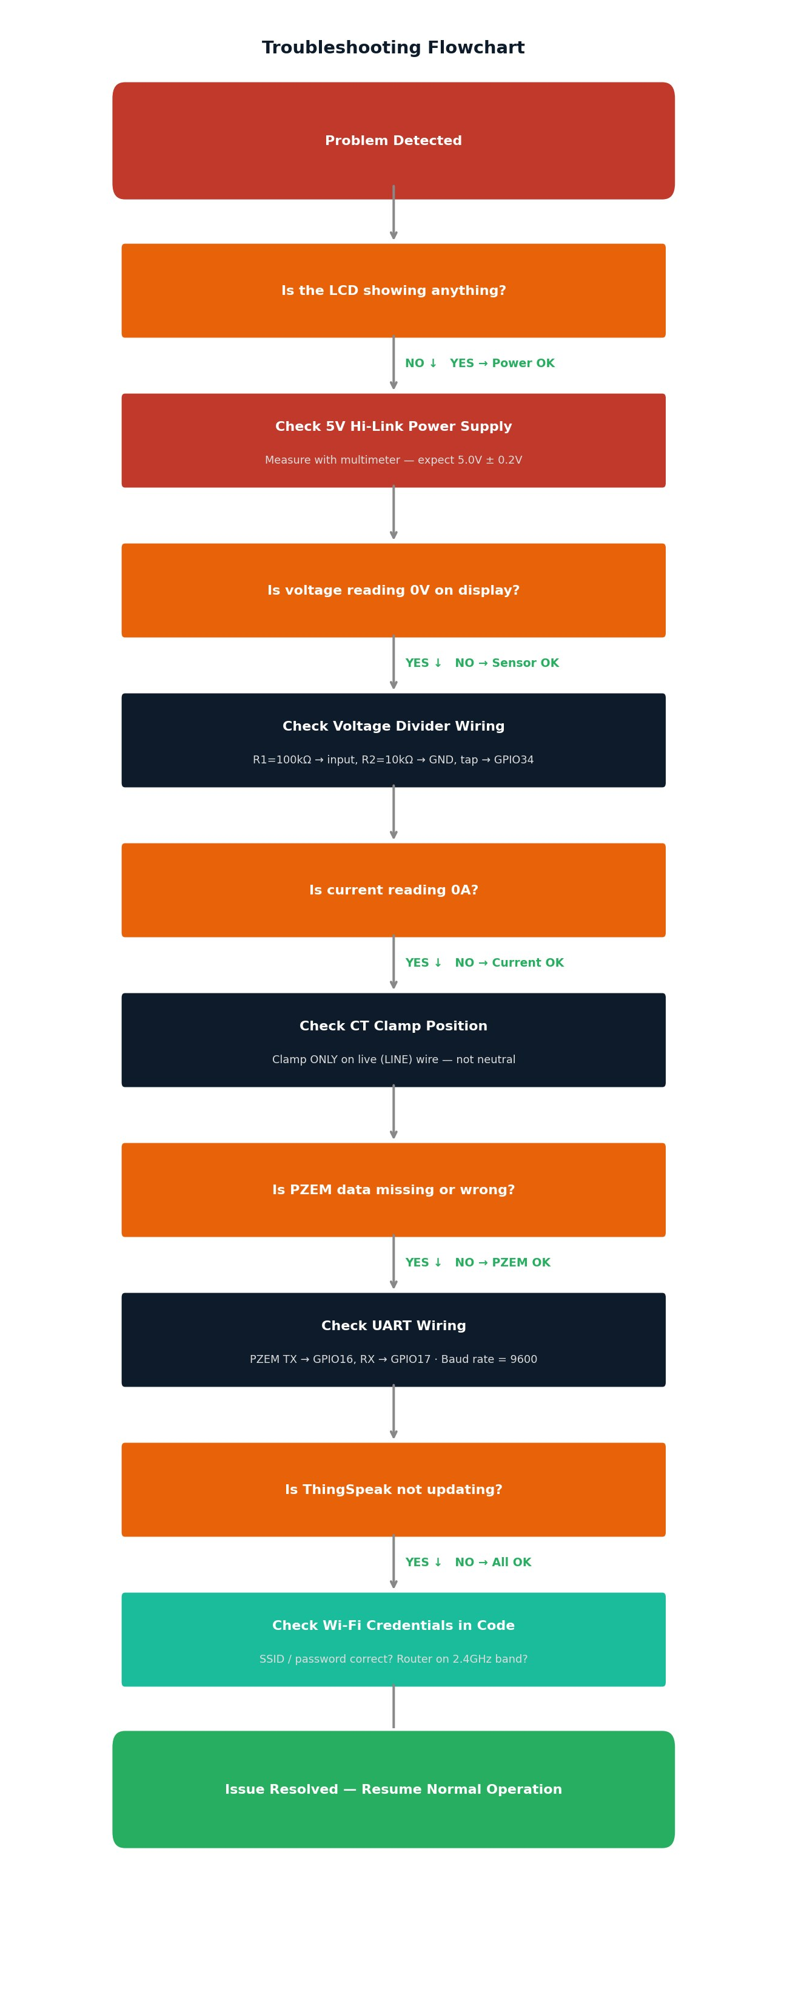

9. References and Data Sheets
Sources

1. Allegro Microsystems. ACS712 Fully Integrated, Hall Effect-Based Linear Current Sensor Datasheet. [Online]. Available: https://www.allegromicro.com/en/products/sense/current-sensor-ics/acs712

2. Peacefair. PZEM-004T v3.0 User Manual & Datasheet. [Online]. Available: https://peacefair.en.alibaba.com

3. Espressif Systems. ESP32 Technical Reference Manual. [Online]. Available: https://www.espressif.com/sites/default/files/documentation/esp32_technical_reference_manual_en.pdf

4. Hi-Link. HLK-5M05 AC-DC Power Supply Module Datasheet. [Online]. Available: https://www.hlktech.net/index.php?id=634

5. ThingSpeak Documentation. MathWorks — ThingSpeak API Reference. [Online]. Available: https://www.mathworks.com/help/thingspeak

6. Espressif Systems. ESP32 Arduino Core Documentation. [Online]. Available: https://docs.espressif.com/projects/arduino-esp32

7. randomnerdtutorials.com. ESP32 with ThingSpeak Tutorial. [Online]. Available: https://randomnerdtutorials.com/esp32-thingspeak-publish-arduino-ide

8. LiquidCrystal_I2C Library Documentation. [Online]. Available: https://github.com/johnrickman/LiquidCrystal_I2C

9. Professor Lazaros Pavlidis. ETEC-495 Course Syllabus and Guidelines, Spring 2026. NYIT Department of Electrical and Computer Engineering Technology.

10. Social Impacts Associated with the Project

Market Report #1 — United States
The IoT-Based Smart Energy Monitoring System Using ESP32 is perfectly positioned for the growing smart home market in the United States. American consumers are increasingly energy-conscious, driven by rising utility bills and growing environmental awareness. The system's core value proposition — real-time visibility into your home's energy use from any device — speaks directly to this audience.

Key selling features for the US market include:
• Real-Time Monitoring: See exactly how many watts your appliances draw — right now, not at the end of the month on your bill.
• Wi-Fi Connected Dashboard: Access your energy data from your phone, tablet, or laptop from anywhere on your home network.
• Affordable DIY Kit: At just $86.41 in parts, this system costs 71% less than the Sense® monitor ($299) and saves over $330 in the first year alone when subscription fees are included.
• No Subscription Required: Unlike every major commercial alternative, this system has zero monthly fees. The data belongs to the user — no cloud lock-in, no recurring charges, forever.
• Educational Value: Ideal for STEM students, makers, and hobbyists who want to learn IoT, embedded systems, and energy management simultaneously.

Marketing channels for the US market would include Kickstarter/Indiegogo crowdfunding, Maker Faire demonstrations, Reddit communities (r/homeautomation, r/DIY), and YouTube build tutorials. A polished GitHub repository with full documentation would attract the open-source community and generate organic interest.

Market Report #2 — India
India is one of the world's fastest-growing energy markets, with millions of households gaining electricity access each year. However, power outages, fluctuating voltage, and high electricity costs (especially in urban areas) make energy awareness critical. The IoT-Based Smart Energy Monitoring System Using ESP32 addresses these concerns at a price point well within reach of India's growing middle class.

For the Indian market, the system's messaging would shift from lifestyle convenience to economic necessity:
• Save on Your Monthly Bill: Know exactly which appliance is wasting electricity and act on it immediately.
• Protect Your Appliances: The voltage monitoring feature (via PZEM-004T) can alert users to dangerous voltage fluctuations — a common problem in Indian power grids — before they damage sensitive electronics.
• Works on 230V / 50Hz: The PZEM-004T supports both 120V and 230V systems, making the hardware fully compatible with India's grid standard.
• Locally Sourceable Parts: Arduino and ESP modules are widely available in India through stores like Robocraze, Robu.in, and Mouser India, keeping costs low and replacement parts accessible.

In India, marketing would focus on electronics marketplaces like Flipkart and Amazon India, YouTube tutorials in Hindi and regional languages, and partnerships with engineering college labs. Government initiatives around smart metering (India's RDSS scheme) also create an institutional market opportunity for an affordable monitoring solution.

— End of Report —

